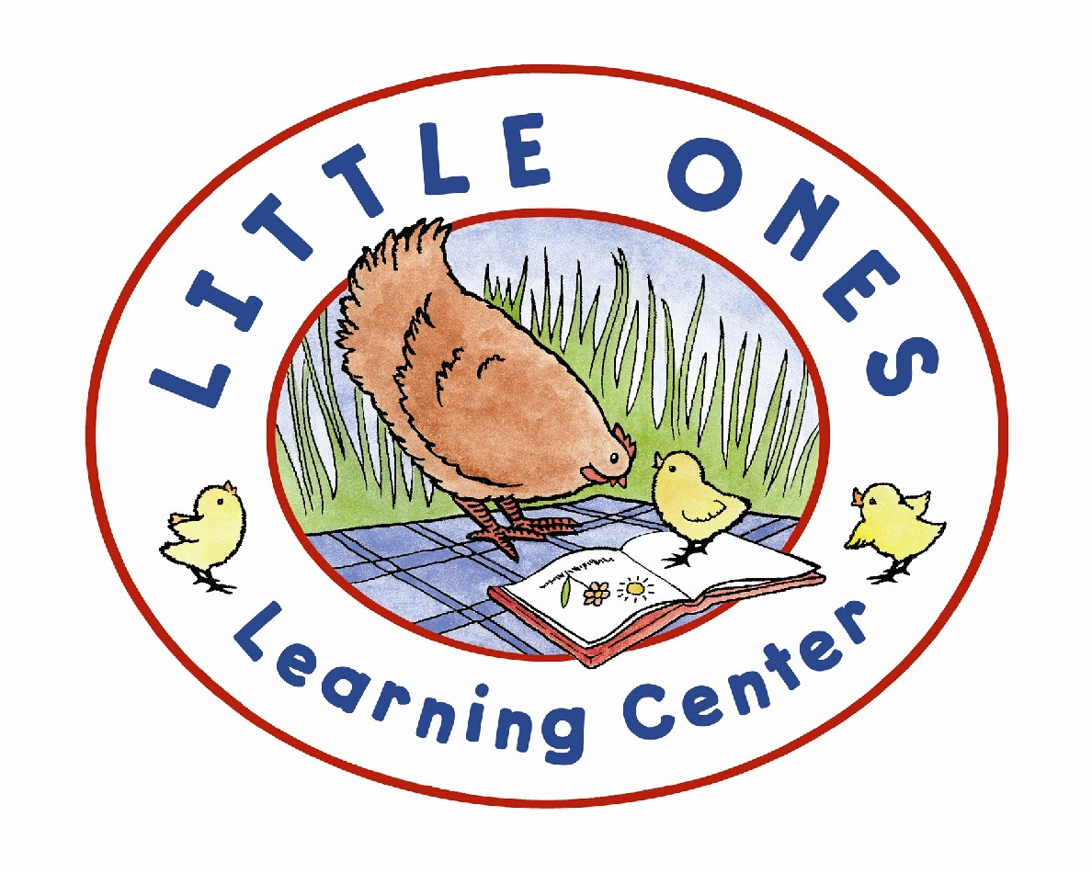
The Little Ones Learning Center, a FREE non-profit early literacy center for children 0-6, is conducting the 2016 Towpath Run, a 6K (3.7- mile), Race/Walk for Literacy, Sunday, Sept. 25, 2016. The race/walk will be run point to point from Alligerville to Accord to raise money for the program.

Runners and walkers will meet at the Accord community center to register from 7:30 a.m. to 8:30 a.m. Runners and walkers will be bussed to Alligerville for the run back to Accord. Walkers will start at 9 a.m., and runners will start at 9:15 a.m.

The race will be run along Towpath Road, a scenic, wooded lane with views of the Catskills, and up the hill from the actual towpath used for ferrying boats along the former D&H Canal. Accord and Alligerville were stops on the canal. There will be no parking in Alligerville, and all runners and walkers will be required to be bussed to the start point from Accord.

Registration can be completed at www.littleoneslearningcenter.org via RunSignUp. Open the calendar page and click “Sign Up” for easy online registration or simply return this completed form to register for the event. Pre-registration by Sept. 16 - $18. Day of Race - $20.

Prizes will be awarded to the Top Three male and female finishers in age groups: 14 & under, 15-19, 20-29, 30-39, 40-49, 50-59, 60 and over, Town of Rochester residents and walkers. The community center is located a few blocks off Route 209, about six miles south of the intersection of routes 209 and 213 in Stone Ridge and about four miles north of the intersection of routes 44/55 and 209 in Kerhonkson.
- - - - - - - - - - - - - - - - - - - - - - - - - - - - - - - - - - - - - - - - - - - - - - - - - - - - - - - - - - - - - - - - - - - -
Read This Completely Before Signing: Release: I hereby certify that I am adequately fit to run this race. In consideration of the acceptance of this entry, I, the undersigned, for myself, my personal representative, beneficiaries, and heirs, knowingly waive, release, and discharge any and all rights and claims which I may have hereafter accrue to me or my estate against the Little Ones Learning Center and the Town of Rochester and/or any other sponsors, organizers, volunteers and assigns for any and all injuries or death suffered in the event. I will also allow my picture and name to be used in publications as a result of this race.

Signature: _________________________Parent (under 18):___________________________

Print Name: ____________________________________Phone Number:_________________

Address_____________________________ City:__________________ State:____ Zip:_________

Sex:____ Age Day of Race: ____ DOB:______ Race Category: __________________________

Contact in Emergency__________________________ Phone__________________

Email address _________________________________________________________

T-Shirt Size: S-M-L-XL (circle one) Run or Walk (circle one)

Checks can be make payable to: Friends of Little Ones, Inc.
And sent to: 5142 Route 209, Accord, NY, 12404
For more information: Contact Bond Brungard at 845-430-0251 or towpathrun@yahoo.com

